Background Information
The student that I chose for my case study project is a 7 year old 2nd grader named Madison who is in my class. Madison comes from a divorced family and is the oldest of four children. She is a very independent girl and is at level in all my subjects. Madison is in one of my highest reading groups and is a great reader, but sometimes struggles with her retelling. One day she could read a passage from a book and be able to tell you what happened in the book from beginning, middle and end. Other days she might read another passage from a book and struggle with answering some of the questions. One of the reasons why I chose her to do my case study on is because she is a very successful reader, but sometimes will struggle with comprehension. Sometimes when looking at the things she is struggling with I wonder to myself if she is lazy or if she is truly lacking in the area comprehension. In one of the articles from Cromley, J.G. they talked about students met cognitive monitoring skills when they are reading. This made me think of Madison and if she was monitoring what she was reading or just reading to read and not understanding the contexts.
My hope is that through my one on one lessons with Madison she will make connections with her comprehension and be able to build onto the knowledge she has and get stronger in this area. (Strands II and III) When looking at ways to help her achieve this goal I used the book Read and Understand with Level Texts by: Evan-Moore Educational Publisher for my one on one mini comprehension lessons with her. This was a great resource for me to use to help her gain better understanding of comprehension as well as how to look in the text for help to answer questions. Through my mini lessons my goal for her was to see her grow and to see if she was comprehended what she was reading.

Design of Case Study
The first lesson I did for my case study was have Madison do a reading aptitude
Test by: Read, Write, Think (Attachment 1). Having Madison take this reading aptitude test
helped me see what type of genres she enjoyed and maybe some genres she didn’t like. By doing the test it will also give me some insight maybe on if it’s the text she doesn’t like reading and that’s why she is struggling with comprehension or if she truly does struggle with answering questions from the text. I started the lesson out with going over the test with her on what it was and why we were doing the test. Once I went over the test with her I let her do the test on her own and if she had any questions I helped her with them. (Strand V) While Madison was taking the test I observed and took notes on how she was answering her questions to see if there was a pattern to how she was answering her questions. A majority of her answers talked about how she liked mysteries and enjoyed animals. After Madison finished the test her and I went over her answers and talked about what she thought about the test and what she thought about her answers. She told me that she really enjoyed reading about mysteries and animals and those were books that she was really interested in. When concluding my lesson I asked her if she thought after she read a passage in a book and answered questions what she thought she struggled with. Her response to that was that she sometimes didn’t understand how the question was worded and the way it was worded got her confused. Once the lesson was over I went over her test again comparing what I took notes on and what she had written down. The first lesson to me went very well and showed me that when I start doing our mini comprehension lessons I know the types of reading that interests her and will see if by giving her genres she likes reading about will help her in comprehending the text and also mix up with different genres.
Over the course of eight weeks I did twenty minute mini comprehension lessons with Madison. When doing my research on what resource I should use I decide to go to my Title 1 teacher to help me find a book that would help with building on with comprehension skills that could be done in a twenty minute time period. After looking at several books in our teacher resource library her and I thought that the book Read and Understand with Level Texts by: Evan-Moore Educational Publisher would work really well for my students because they are mini stories with different comprehension questions you can do each day for the whole week. The layout for the book was also very good and was easy to teach to her. There was one lesson format I used for the whole eight week period when teaching my twenty minute mini comprehension lessons (Attachment 2).
Format of Lessons for mini comprehension
Monday: Every Monday a new mini story was introduced on Monday she would read the book the mini story and we would discuss what the story was about; characters and what she thought grabbed her attention while reading the story.
Tuesday: We started out by reading the story and doing a KWL chart. (What We Know, What We Want to Learn, What We Learned, How We Know We Learned It) This is a good way to see the story more laid out to help her when answering the questions.
Wednesday: She and I would go through the multiple choice questions for each question she would go back in the text and highlight to find the answer. This is also a method we use in our district to prepare students for the MEAP by having them go back in the text and finding and underlining the text. For students who struggle with answering questions this is a great way to help them look for the answering in the reading.
Thursday: She and I would look at how to look at how to fill in the blanks and how to approach to answer mini essay questions. Also I would have her go back in the text with a different color highlighter to find the answers for the fill in the blank and mini essays. Once she finished answering them we would go over her answers to see how she approached them.
Friday: Ever Friday wrapped up the mini story for the week and at the end of each lesson it had a test that they would take to see how they understood the story. When taking the test which was usually eight questions of less the student couldn’t use the book. After each test I would grade it and then her and I would go over the answers she got wrong and talk about what she might have missed and look at what she might have struggled with on the answers that she missed.
Within the eight weeks I did this format every day with her for twenty minutes in the morning during morning work (Attachment 3). In addition to this after week three I did more in depth work one on one helping her with comprehension by giving her a Venn diagram to use to see if that would help her see more visually some of her answers (See Attachment 5). When doing the lessons with the Venn diagram we read the story and then set up the Venn diagram with comparing the two characters in the story and seeing how they were different and the middle of the Venn diagram was how they were the same. By her seeing this visually and looking at the diagram to see how their different did help her when I asked her questions about the two characters in the book. She used the diagram as a way to help her answer the questions without going back in the reading because she had already compared the two characters and could see visually how they were different and how they were the same. This to me showed that by having her break down the reading and map it out using a Venn diagram helped her comprehend a little more than just going back in the reading and trying to remember the text. The next two weeks after that she did very good making use of the Venn diagram I decided to make the reading more complex and have her read a mystery about who stole the dog bone. I wanted to see if I gave her a problem that was happening throughout the story could she use a different type of graphic organizer to help her. Once we read the book we talked about what the problem was in the story and how we were going to figure out who stole the dog bone. Once we went over that I then introduced a new type of graphic organizer. The graphic organizer I introduced her to was four square. In a four square set up you give a student a piece of paper that is split up into four squares. In each square you give the students whether something you want them to put in them for instance details in a story, beginning, middle, end, problems in a story and maybe details about the characters in the story. When giving her the four square we did four different characters in the story and got information on where each of them were when the dog bone was stolen. Madison really enjoyed doing this because she said “I feel like I am a detective trying to look at each character and figure out who did it” she really did enjoy breaking down each of the characters to find out which one had stolen the dog bone. After she put all her information down on her four square I asked her questions about each character to see if she could see visually who stole the bone from the information she wrote down about each character. When asking her the question “Where was the dad when the dog was bone taken?” She answered with “looking at my square he was at work so he couldn’t have been the one who took the bone” I asked her another question “Where Mike was the cat when the dog bone was taken? She said “well Mike was the only one where they never said where he was at so he has to be the one who stole the bone”. We read the last page and she was right that Mike the cat was the one who stole the bone. I asked her how she felt about using the four square and how it helped her know he was the one who stole the dog bone. She replied with “when I looked at my four square it helped me see he was the only one who didn’t say where he was at the time the bone was taken so it had to be him”. I was very proud of myself in this lesson because not only did the four square help her in finding out who stole the bone, but it also helped her grow with adding details and looking back at her four square to help her gain better understanding of the content she is reading (Strand III).
Post Assessment
To find out whether or not my student comprehended the material by using a KWL chart and a four square for helping her comprehending the text she took a post assessment test (Attachment 6). The post assessment focused on whether or not the new strategies she learned helped her gain a better understanding of comprehension of reading text. By having her take the post assessments also made her use the strategies she learned over the past couple of weeks and apply them. In an article we read by William, J.P. it talked about using graphic organizers as a way to assess student’s comprehension of what they were reading. Another part of the article that I enjoyed was how it gave ideas when using a graphic organizer to help test a student. This article made me think of using a graphic organizer as a way to help her when answering her questions for her test.
When I gave her the post assessment there was only three multiple choice and three filling the blank questions. The test was from my Read and Understand with Level Texts by: Evan-Moore Educational Publisher which I had been using for over the past eight weeks. I chose to continue with this book because she had been use to the format because that is what we had been doing for over the past eight weeks so I didn’t really want to change the format especially because it was a post assessment to see how she comprehended what she had learned over the past couple of weeks.
When she took the test she read the mini short story first and then I gave her the option if she wanted to use both KWL chart and four squares or just one of the graphic organizers to help her with answering the questions. She actually chose to just go back in the reading and answering the questions. As she went back and highlighted her information for the answers she answered her questions from the information that she highlighted. While she was writing her answers down I prompted her with some questions. I had her stop after she did her three multiple choice questions and asked her how she knew those were right answers to her questions. She responded with “these were the right answers because even though I didn’t do a four square of KWL chart I could see the answer when I highlighted it in the text.” From that she then said she knew the answers to the next three fill in the blank questions to from looking at what she highlighted and remembering the important parts of the reading that she read. I was really impressed with her memory recall. At first when she took the test and chose not to use the KWL chart and fours square that we had been doing over the past couple of weeks I was a little worried because that is all we had been doing and I wasn’t sure if she could do it with just going back in the text and highlighting. Once watching her use two different highlighters to answer one for multiple choice and once for fill in the blank I was really impressed with how she answered all the questions without using the methods we had been doing and got all her answers correct. She was very excited as well to see that she had done a great job and she felt very proud of herself.
Over the past couple of weeks I have really seen her grow in comprehension and she to me feels more confident with comprehension. By using the comprehension strategies of the KWL chart, four square, and the book Read and Understand with Level Texts she grew in comprehension.

Changes after Using Comprehension Strategies
Knowing her previous background that her reading skills are very strong and are at level for where she should be this time of year in reading that wasn’t my main focus when assessing her in pre and post assessment (Attachment 4). My main focus for the study was to see her growth in the area of comprehension of text that she is reading. When looking at what I used for the pre-assessment on what types of reading she enjoyed and focusing on whether or not this wasn’t just her being a lazy reader, but grasping a better understanding of the types of reading she truly does enjoy. This made my Title 1 teacher and I find a resource tool that would help us focus on the things that she enjoys reading to see the impact this would have on her comprehension skills. By choosing the resource book Read and Understand with Level Texts by: Evan-Moore Educational Publisher this did benefit her and help her gain better understanding of comprehending what she is reading.
When looking at the post assessment and seeing how she passed the test I was really impressed again that she did make use of the using her comprehension strategies even though she didn’t use KWL chart and four square. She was still able to answers the questions and gets them all right. Since the post assessment she has been doing different types of comprehension sheets with whole group and in her reading group and I have noticed that she has made use of some of the strategies she has worked on. Last week she came up to me and said that she really liked using the four square to help her with a paper she was doing on her chapter in her reading book on Nancy Drew. When I asked her what she was doing in her four square she responded with “I’m using the four square to help me find out where Nancy and Bess lost the doll.” I told her “how do you think this helped you answer the question on where the doll was?” She replied with “ it showed me which character wasn’t at the house at the time they were all suppose to be there and it told me that maybe that person is the one who might have taken the doll or they know where the doll is.” She really did make use of the four square and it helped her in her chapter book to help her layout the information more visually for her to find out where the doll was and who might have the doll.
Through the exposure of the different comprehension strategies of using a KWL chart and four square she gained a better understanding and grew in her comprehension skills. She also to me feels more confident about answering her questions independently and gaining better knowledge of the subject area she is reading. She has not only used some of her comprehension strategies in just language arts, but also in science and in social studies. By having her gain more knowledge onto her comprehension skills will help her become more confident in herself.
Final Thoughts
Looking back on the case study that I have been doing over the past couple weeks I think the comprehension strategies I used on my student could be used on all various types’ learners. The one thing that I noticed that I would really love to do in the future with my students is have extra time with them to see where they are lacking in their comprehension skills. By this I mean are they at beginning, middle or high level of grasping comprehension skills. I think if I could meet with every single student for at least a couple of minutes a day it would be interesting to see where they are in their comprehension skills at the beginning of the year and where they have grown towards the end of the year. This would be something that I would really like to try in the fall and put in my literacy monitoring notebook. It would also be good to track students who are struggling throughout the year on certain concepts and trying different graphic organizers to help them grow in their comprehension skills. One thing that I would change about what I did my student was make sure that maybe she could have read towards the end chapters from her reading book to see if she could use the comprehension strategies that way that from just using them from the Read and Understand with Level Texts by: Evan-Moore Educational Publisher. This to me would have been interesting also because it would have let me see if she could read a full chapter from the book and be able to go back and answer questions from the book. Finally, I also would have added more graphic organizers and saw which one she would have liked and not just stuck with the two that I used. These ideas I feel are things that I would implement in the future when looking at different comprehension strategies to use with students.
Watching the student I chose grow into making use of the comprehension skills she used over the past couple of weeks makes me feel proud of a job accomplished in a short amount of time. The strategies that she used not only will help her now, but will also help her in grades to follow. By doing this case study as a teacher it showed me areas that I should also take a better look at and focus on areas that students may struggle in and I might not know unless I do mini lessons or whole group strategies on the topic. Not only has it opened me to new things I need to try in the future, but it also showed me that any student no matter what level they are at can benefit from learning in a small or whole group setting on a mini lesson on certain topics and they will grow over time with just a extra couple a minutes a day with learning a new strategy.
I’m very excited that I had the opportunity to do this case study on comprehension strategies with the student I chose. I’m glad that I chose her because even though she was a strong reader she lacked in comprehension. Some teachers would probably skip over this because her reading is at level and they would assume because the student is reading at level then they can also comprehend the text one hundred percent. So when looking at your students you need to make sure that no matter what level they are at there is something that each of them are probably lacking in and it is our goal as a teacher to find that one thing they are struggling with and help them achieve that goal in that area. If every teacher could take the time and do that with their students you would probably see a huge increase in language arts. Finding the perfect strategy with a student will open up their eyes to a whole new way of being excited about learning!

References

Cromley, J. G. (2005). Metacognition, cognitive strategy instruction, and reading in adult literacy
Evan-Moore Educational Publisher. (2006) Read and Understand with Level Texts Grade 2.
Freeology.com. Free School Stuff.
Keene, Ellin. 2006. Assessing Comprehension Thinking Strategies. Shell Educational Publishing.
Williams, J. P. (2005). Instruction in reading comprehension for primary-grade students: A focus on text structure. Journal of Special Education, 39, 6-18.

Reading Aptitude Survey Attachment 1
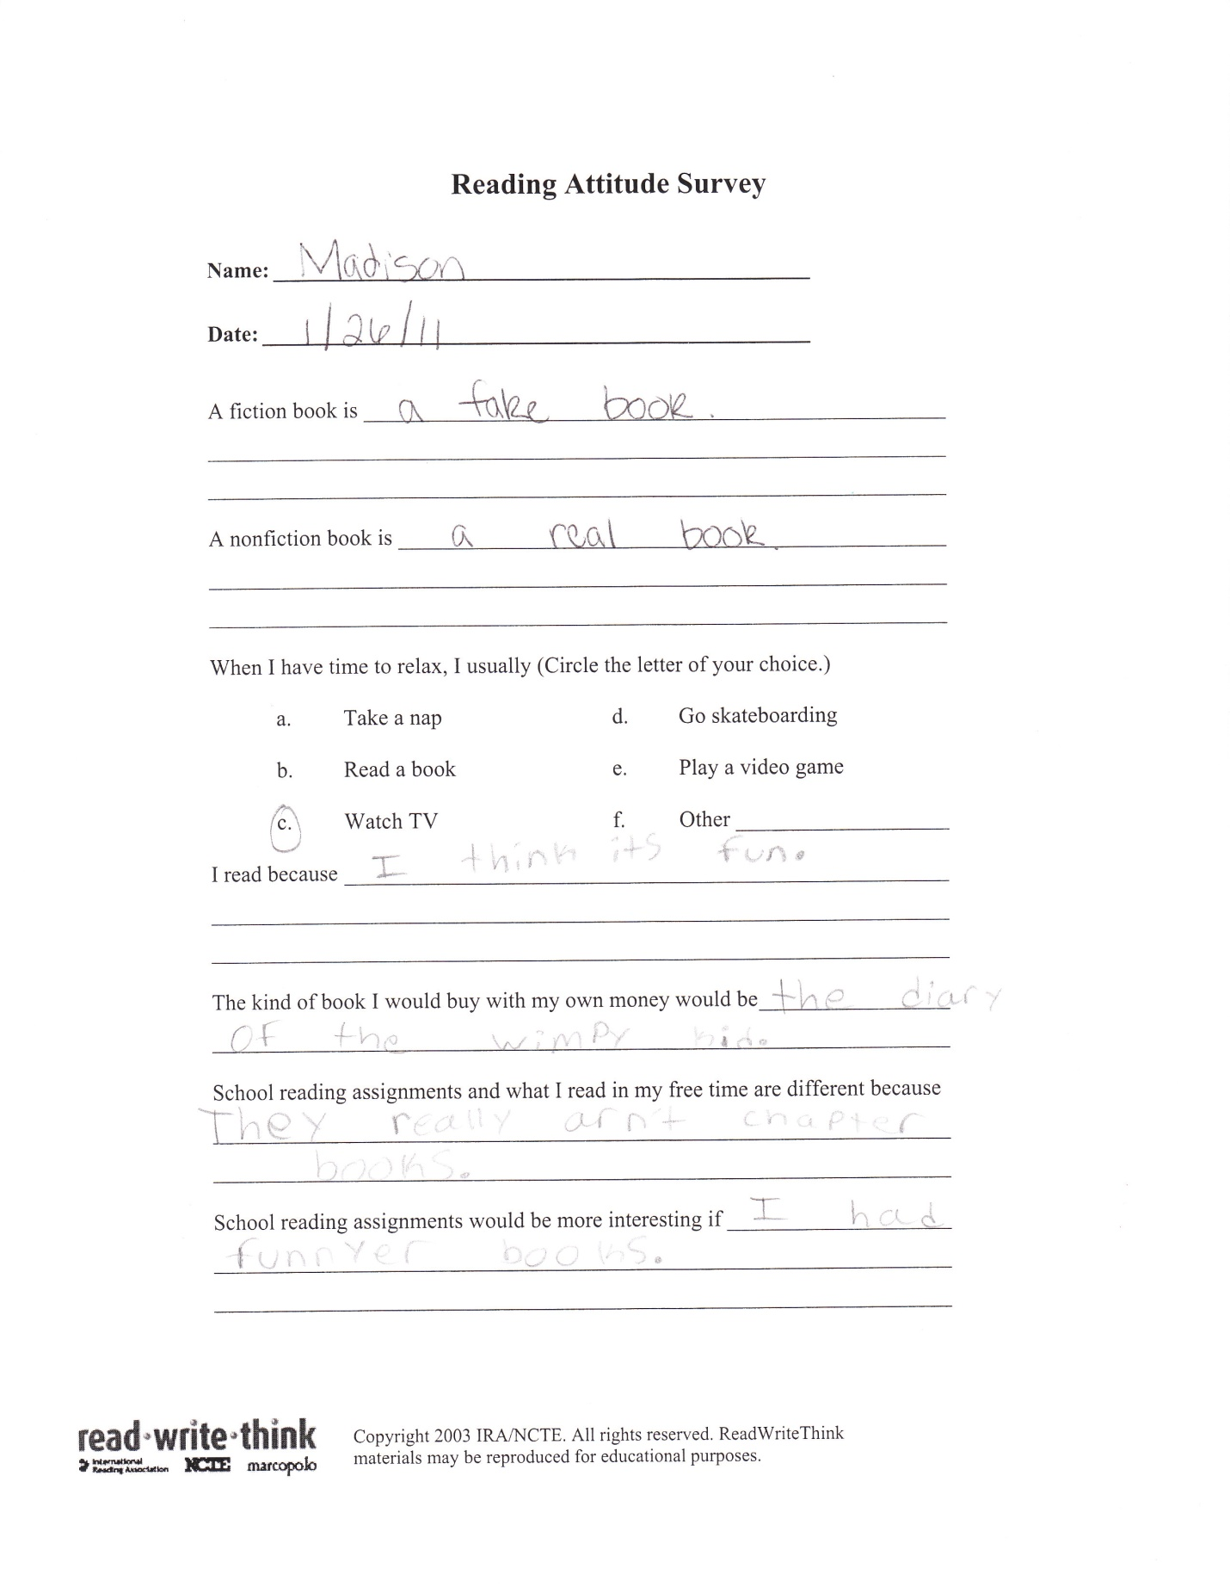
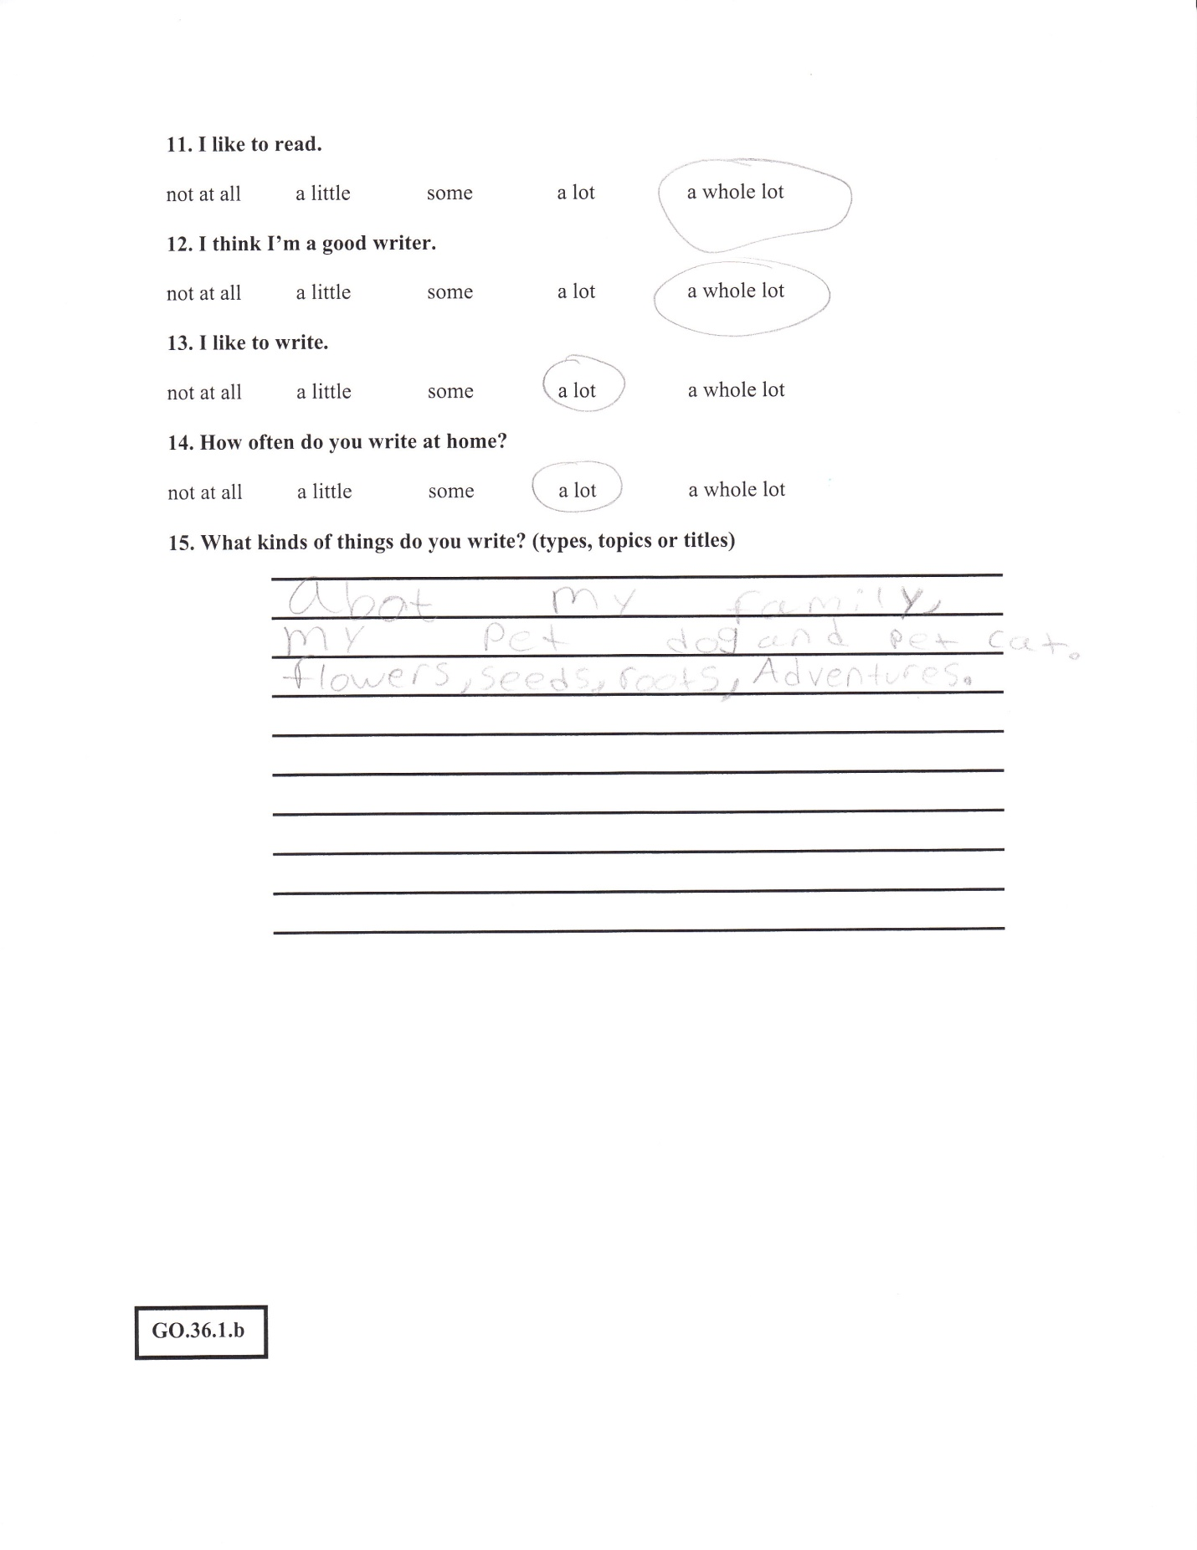

Attachment 2 (Lesson 1)
Lesson: Reading Attitude Test

Subject: Reading Attitude Test

Grade Level: 2nd Grade

Date: January 26, 2011

Duration: 20 minutes- during morning routine work (one on one lesson)

Lesson Objectives: In this lesson I wanted my student to take a reading attitude test to see what types of books she likes and dislikes.

GLCE’s:

R.8.1.a Use pictures/graphics to make predictions about text, and discuss conclusions.

R.6.1.b Use prior background knowledge to approach text

Materials: Reading Attitude Test by Read, Write, Think (See reading aptitude test attached)

Resources: Reading Attitude Test for students to take

Rationale/ Background: Having the student take the reading attitude test will help me get a better understanding on what types of books the student likes to read. By doing the reading attitude test it will help me also see if the reason why the student might not comprehend the text is because they aren’t enjoying the types of books they are reading or that there is a comprehension problem.

Opening: The teacher explains the reading test that is going to be given to see what type of reading they like or dislike. Go over the test with the student about how to answer the questions whether in a sentence or list form for some of the questions.

Middle: While student is doing the test I observed how she was looking at each question. Couple of the questions after she answered them I asked for her to explain her question orally.

Conclusion: After the student is done I look we go over the reading aptitude test together and look at the how she answered the questions. Once I have gone over the test with her I ask her if there is anything else she wants to add to any of the questions or ask me about the test. When the student is done she goes back to her seat and continues with her daily morning work.

Adaptations and Extensions: After looking at the reading aptitude test I can then start looking at her interests in reading. Are there things that she enjoys reading more than others? Or does she simply not comprehend the text that she is reading? My extensions over the next couple of weeks will be having her do mini comprehension reading tests. On top of that I will also do mini lessons with her.

Assessment: This was one assessment that was given so I could see what it she likes and learn more about her as a reader. I will be giving her mini comprehension quizzes throughout the next couple of weeks.

Attachment 3 (Comprehension Work Note)
Comprehension Work:
Over the next couple of weeks part of Madison’s work will be comprehension read and understand mini readings with comprehension questions.
Ever week she will get the reading on Monday and will do little questions throughout the week and on Fridays will take the comprehension test.

Evan-Moore Educational Publisher
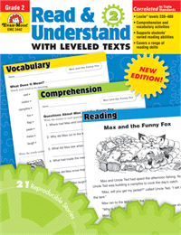
Week of:
January 31-Feb. 4
Lesson 1, we go over the reading together and talk about the story and what is happening in the story. Once we have talked about the story Madison pointed out that the dog looked like her dog and that she loves dogs. She was very excited about reading more about the dog playing outside in the yard after noticing that the dog looked like hers.
On Friday she took the comprehension test which was out of 5 questions. She got 2 out of 5. After the test we went over the answers she said some of the wording confused her when they asked why you thought the dog was playing outside and not indoors.

Feb. 7-11
Lesson 2, since she liked dogs I found another reading on dogs, but this reading dealt with two different types of dogs a German Sheppard and a Poodle. She read the story and we talked about words that were new and highlighted them. We also did a Venn diagram of the two different types of dogs and also what they have in common. This really worked for her visually seeing the differences between the two and what the same were.
Friday she took the test which was out of 6 and got 4 out of 6. We talked about the two questions she got wrong which were about how the dogs were alike. So we talked about what the word alike meant and how on her Venn diagram we had it down. After pointing it out she understood what it meant.

Feb 14-18
Lesson 3, this week we had two snow days so I shortened out lesson and took a reading with comprehension out of my edhelper.com folder. The reading was about a winter storm and what caused the storm. I was very shocked when only doing the lesson for 3 days that when she took the test out of 8 she got 7 out of 8 right. When we went over the test she was very excited and said she knew the last question, but guessed wrong.

Feb 21-25
Lesson 4, this week we had 3 ice days so we did a mini lesson on Venn diagrams. We picked winter and spring and compared the two and talked about if there was anything that was the same about both. We then wrote out sentences comparing the two seasons and then talking about which ones were the same. Through this mini lesson I could see that she was developing more in her ability to read and comprehend on her own with more confidence.

Feb 28-March 4
Lesson 5, for this lesson we read a story about a party and how someone stole a present. She really enjoyed this reading because she had the opportunity to try and learn through the questions who stole the present. I could tell in this lesson she was very independent and was more confident when answering her questions. We also did a 4 square story map for this reading. She really enjoyed laying out all the parts of the story on the 4 square and looking and how to apply her answers to her questions from the reading.
On the test on Friday she got 8 out of 8.

March 7-11
Lesson 6, for this lesson we read another mystery story this story was about someone who stole a book from the library. Again we used a 4 square story map and she was independent at answering the questions. On Friday after she took the test we talked about how she thinks she is coming in comprehending the text she is reading. Things that she thinks are helping are using the 4 square and Venn diagram. One thing that she still thinks that confuses her is when answering questions they want to know what happens after something in the story sometimes she said she gets confused if they mean and the beginning, middle or end. This is something that I am going to work on next with her and use the story map to incorporate it.

March 14-18
Lesson 7, for this lesson I focused on working on another mystery mini story that was in the book. She really enjoys mysteries and I think they also help her with the part of comprehension that she is struggling with. After reading the story and filling out our 4 block I set the 4 block up into Beginning, Middle, End and the extra box we used for any other important detail that we should put in there. I noticed by using the 4 block in this way she really grasped the concept of breaking up the story and looking at it in 3 or 4 different ways.
Her comprehension quiz on Friday she got a 5out of 6.

March 21-25
Lesson 8, I decided to let her choose from three different stories I had from the book and she chose one on activities to do with dogs. When she set up her 4 block she decided to go with using the beginning, middle and end. When she took the test on Friday she got a 6 out of 6 and she said to me one thing that really helps her out is using the 4 block and setting it up using the beginning, middle and end. I asked her why she thinks this helps her and she said it helps her when answering the questions because it lets her see what part of the story the question is coming from.

March 28- March 31
She was absent the whole week because she went on spring break. I am going to give my last lesson to her the week back from spring break.

April 11- April 15
I gave her the post assessment test from the book and she chose to not use a comprehension strategy of the KWL chart or four square. At first I was concerned because she chose not to use comprehension strategies that we have been working on, but after taking that test and grading it she got a 6/6. She and I reflected how she felt she had been doing over the past couple of weeks in growing in her comprehension and using the strategies that we used over the past couple of weeks.

Attachment 4 ( My oral assessment notes)
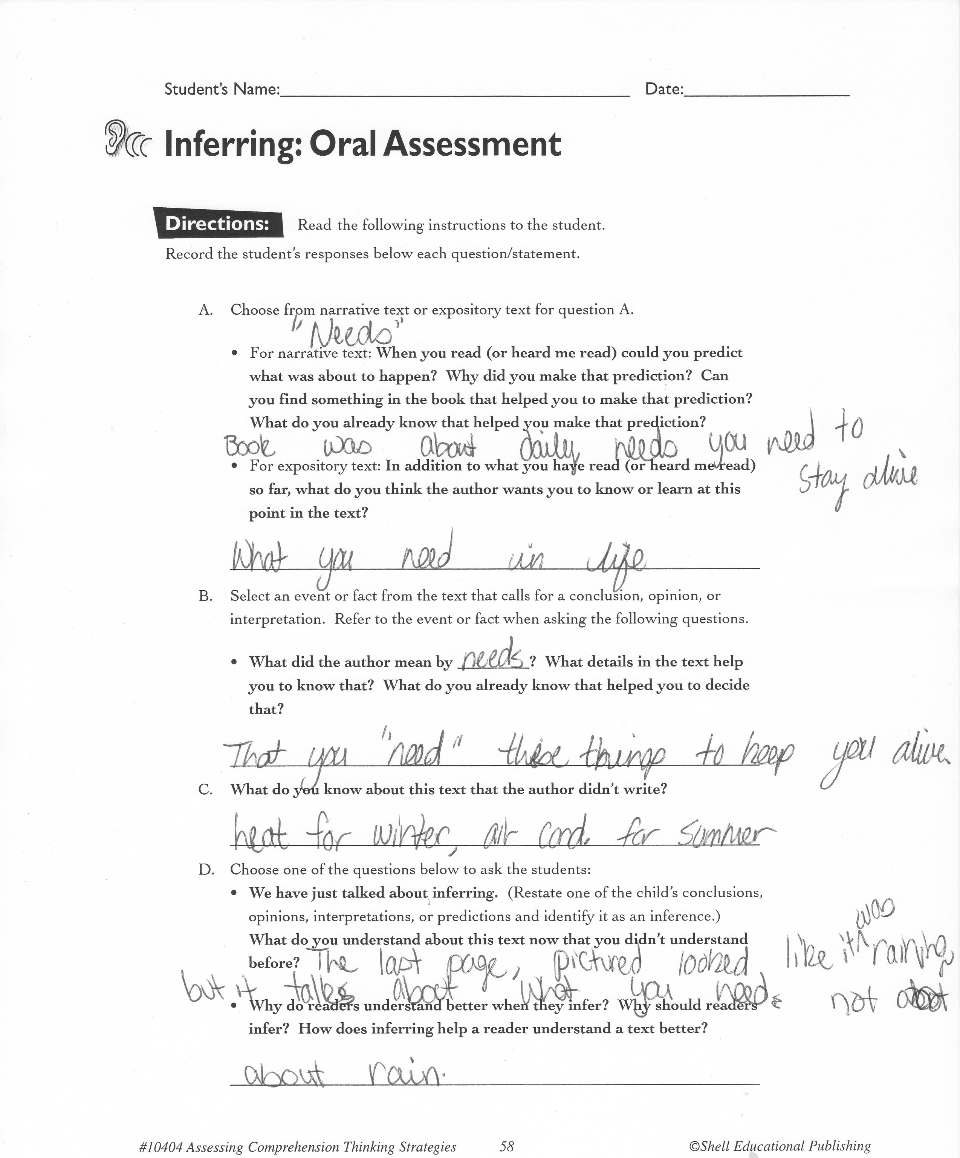

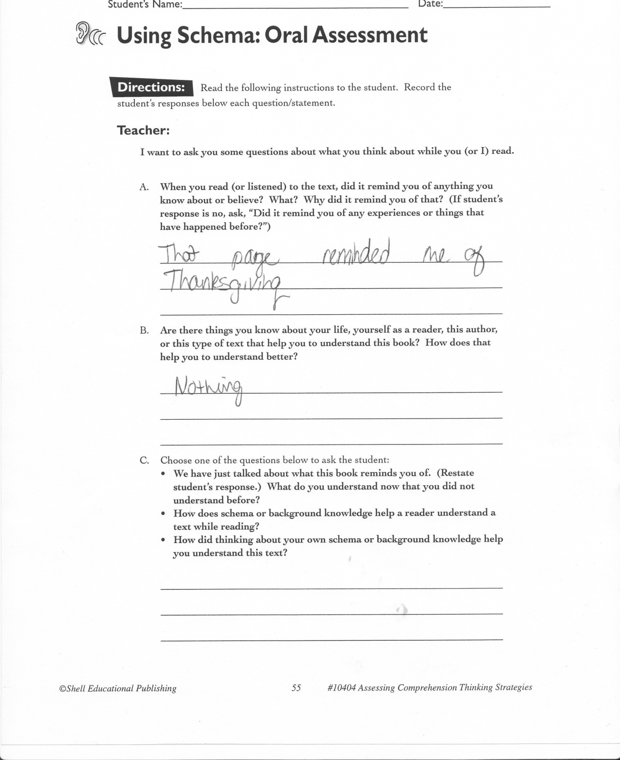

Attachment 5 (Lesson 2)
Lesson: Venn diagram

Subject: Using a Venn diagram to help assist with comprehension strategies

Grade Level: 2nd Grade

Date: March 7, 2011

Duration: 20 minutes- during morning routine work (one on one lesson)

Lesson Objectives: In this lesson I wanted my student look at a graphic organizer that might help her when answering questions from reading text.
GLCE’s:

R.8.1.a Use pictures/graphics to make predictions about text, and discuss conclusions.

R.6.1.b Use prior background knowledge to approach text

Materials: Venn diagram print out for the student

Resources: pencil, mini story from out resource book we are using and Venn diagram, highlighters if needed.

Rationale/ Background: By using this graphic organizer it will help her look visually at the story laid out on paper when comparing characters in a story and seeing how they are the same or different. This will also help her gain more knowledge in comprehension by using a graphic organizer to help her sort out her thoughts on paper.

Opening: Start the lesson out my opening with what a Venn diagram is and going over what each circle is used for and how we are going to use it in the mini story we are doing.

Middle: After reading the mini story with the student here we go over the main two characters in the story. We put one characters name on one circle and one characters name on the other. In this story we are comparing the two characters to find out how they are different and in the middle we are looking at how they are the same.
While the student is filling in the Venn diagram the teacher is asking the student questions on what she knows about each character and how they are the same and different. Once the student has filled in the Venn diagram they can answer the questions and they can refer to the Venn diagram to help them if they need help when answering the questions.
Conclusion: Once the student is done we go over how they filled out their Venn diagram and the teacher can prompt questions again towards how the students filled in their diagram. The teacher also tells the student that this is another way to help assist them when answering questions and can help them in the future.

Adaptations and Extensions: The student can use the Venn diagram in the future to help them assist them when answering questions.

Assessment:. I will be giving her mini comprehension quizzes throughout the next couple of weeks.

Attachment 6 (Four Block)
